Social media tags for all posts

Organisation | LinkedIn | Facebook | Instagram | X
Plant Health Australia | @plant-health-aus | @planthealthaustralia | @planthealthaust | @planthealthaust
QDPI | @department-of-primary-industries | @biosecurityqld | @biosecurityqld | @DAFQld

Date | Channels | Copy | Visual
Post 1 | LinkedIn  Facebook  Instagram  X | Looking for something new to keep youngsters busy over the school holidays? @QDPI and @PHA have just launched the Youth Biosecurity Training Hub.  The website is packed with games, activities and resources to teach juniors and teens how to protect Australia from pests and diseases. 🐞🌿  Perfect for curious minds at home or in the classroom.  Developed by @PHA with funding from @QDPI  👉 Check it out: youthbiosecurityhub.com.au  #Biosecurity #YouthBiosecurity #PlantHealth #SchoolHolidays #LearnAndProtect | YBTH video for parents:  YBTH video for parents.mp4
Post 2 | Facebook  Instagram  LinkedIn  X | The Youth Biosecurity Hub makes teaching biosecurity easy. We’ve pulled together curriculum-aligned  resources, all in one place, to teach students how to protect Australia from pests and diseases.  👉 Check it out: youthbiosecurityhub.com.au  Developed by @PHA with funding from @QDPI  #YouthBiosecurityHub #BiosecurityEducation #TeacherResources #FutureBiosecurityLeaders #AgEd #STEMeducation #BiosecurityMatters #PHA #QDPI #CurriculumSupport #ClassroomReady #ProtectOurFuture | YBTH video for teachers.mp4
Post 3 | LinkedIn  Facebook  Instagram | Teach our next generation to protect our Australian way of life, with an easy to navigate website and fun to learn content and activities. Learn today and protect tomorrow on the #youthbiosecurityhub  👉 Discover biosecurity made fun: youthbiosecurityhub.com.au  #Biosecurity #YouthBiosecurity #FutureReady #TeacherResources #LearnAndProtect | YBH Social Educators 2:  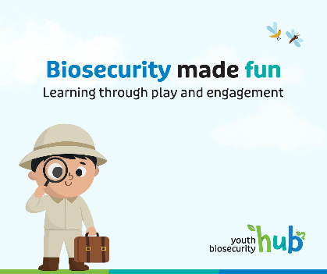
Post 4 | LinkedIn  Facebook  Instagram  X | Calling all teachers! Show students how small actions can make a big difference in protecting our plants, animals and landscapes from threats. Start their learning today by incorporating the Youth biosecurity e-learning course into your lesson plan.  👉Do the eLearning course now: https://biotraininghub.com.au/youth-biosecurity/e-learning/  Developed by @PHA with funding from @QDPI  #Biosecurity #YouthBiosecurity #FutureReady #TeacherResources #eLearning  Due to be released in August 2025. Check webpage before posting. | 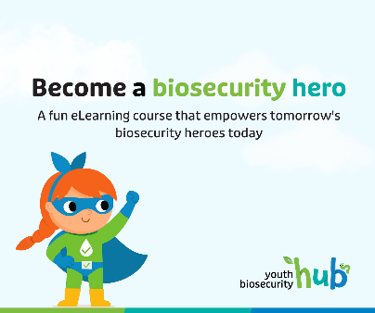
Post 5 | LinkedIn  Facebook  Instagram  X | Biosecurity is as simple as ABC with the Youth Biosecurity Training Hub:  - Access ready-to-use teaching resources  - Build biosecurity knowledge in the classroom  - Create future biosecurity champions  👉 Start here: youthbiosecurityhub.com.au  Developed by @PHA with funding from @QDPI  #YouthBiosecurityHub #BiosecurityEducation #TeacherResources #FutureBiosecurityLeaders #AgEd #STEMeducation #BiosecurityMatters #PHA #QDPI #CurriculumSupport #ClassroomReady #ProtectOurFuture | YBH Social Educators 2:  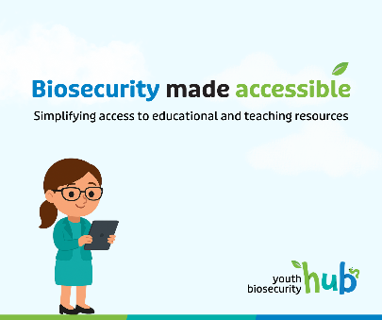
Post 6 | LinkedIn  Facebook  Instagram  X | Explore, engage and empower! The Youth Biosecurity Hub is your go-to website for educational #biosecurity  Resources, built to support Australian educators at every level.  👉 Dive in: https://youthbiosecurityhub.com.au  Developed by @PHA with funding from @QDPI  #YouthBiosecurityHub #BiosecurityEducation #TeacherResources #AgEd #ClassroomTools #STEMeducation #FutureBiosecurityLeaders #PHA #QDPI #ProtectOurFuture #TeachBiosecurity #AustralianSchools | YBH Social Generic:  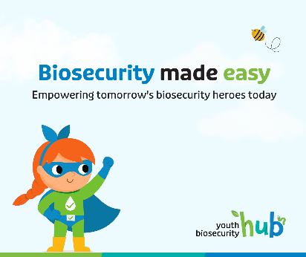
Post 7 | LinkedIn  Facebook  Instagram  X | The youthbiosecurityhub.com.au makes #biosecurity fun and easy to teach. Explore a activities and resources across:  - 🐄animal biosecurity  - 🌱 plant biosecurity  - 🐟 aquatic biosecurity.  👉 Start exploring: https://youthbiosecurityhub.com.au  Developed by @PHA with funding from @QDPI  #YouthBiosecurityHub #BiosecurityEducation #TeacherResources #AgEd #STEMeducation #ClassroomReady #TeachBiosecurity #FutureBiosecurityLeaders #QDPI #PHA #ProtectAustralia #InteractiveLearning | Multi-industry carousel  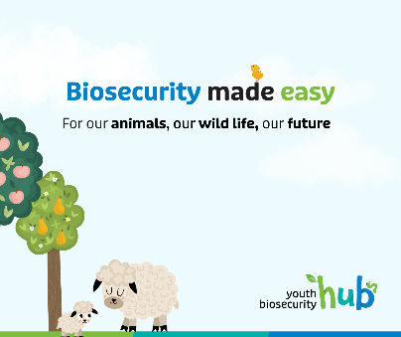  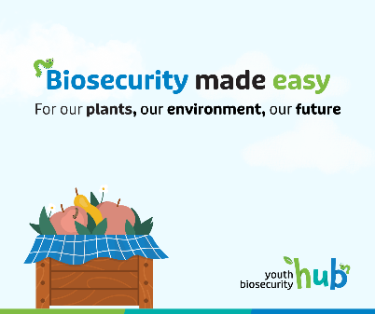  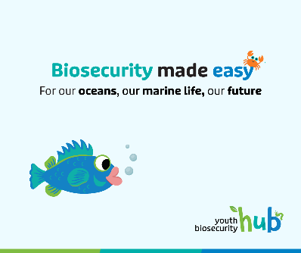
Post 8 | LinkedIn  Facebook  Instagram  X | Turn curiosity into action. The Youth Biosecurity Hub helps teachers inspire the next generation of biosecurity  champions with free, curriculum-aligned resources that make complex topics accessible and engaging.  From lesson plans to interactive tools, it's everything you need in one place.  👉 Explore now: https://youthbiosecurityhub.com.au  Developed by @PHA with support from @QDPI  #YouthBiosecurityHub #BiosecurityEducation #TeacherResources #STEMeducation #AgEd #TeachBiosecurity  #FutureBiosecurityLeaders #ClassroomReady #LearnAndProtect #PHA #QDPI #ProtectAustralia | YBH social 3:  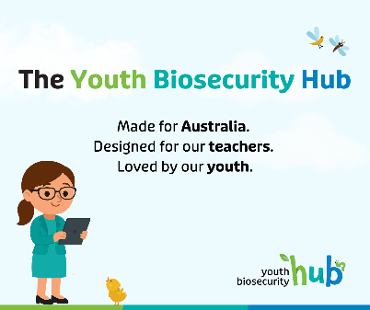
Post 9 | LinkedIn  Facebook  Instagram  X | Teachers, we’ve done the prep for you.  If you're looking for biosecurity resources to include in your lesson plans, the Youth Biosecurity Hub has you  covered.  Get instant access to curriculum-aligned activities, videos, and teaching tools — all in one place.  👉 Explore now: https://youthbiosecurityhub.com.au  Developed by @PHA with funding from @QDPI  #YouthBiosecurityHub #BiosecurityEducation #TeacherResources #TeachBiosecurity #ClassroomReady #AgEd  #STEMeducation #PHA #QDPI #FutureBiosecurityLeaders #ProtectAustralia | YBH social generic 2:  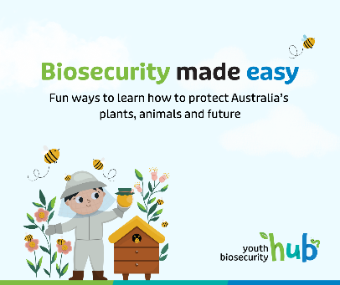
Post 10 | LinkedIn  Facebook  Instagram  X  (aimed at the youth audience) | Learning doesn’t have to be boring.  The Youth Biosecurity Hub is full of fun videos, games and activities that show how you can help protect  Australia’s plants, animals and environment from pests and diseases.  It’s real-world science made interesting.  👉 Check it out: https://youthbiosecurityhub.com.au  Developed by @PHA with funding from @QDPI  #YouthBiosecurityHub #NotYourAverageLesson #STEMlearning #BiosecurityHeroes #ProtectAustralia  #FunLearning #AgEd #FutureBiosecurityLeaders #LearnAndProtect #PHA #QDPI | YBH youth  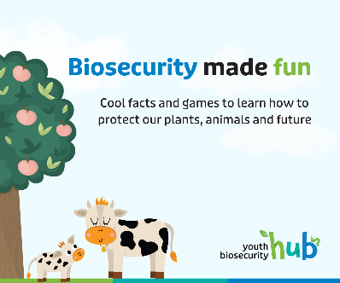
Post 11 | LinkedIn  Facebook  Instagram  X  (aimed at the youth audience) | Ever wondered what #biosecurity is?  It’s protecting plants, animals, fish and our environment against pests and diseases, to secure the future  for all Australians.  Want to learn more?  👉 Check it out: https://youthbiosecurityhub.com.au  Developed by @PHA with funding from @QDPI  #YouthBiosecurityHub #NotYourAverageLesson #STEMlearning #BiosecurityHeroes #ProtectAustralia  #FunLearning #AgEd #FutureBiosecurityLeaders #LearnAndProtect #PHA #QDPI | 